8.1 Sampling distribution of a sample mean.
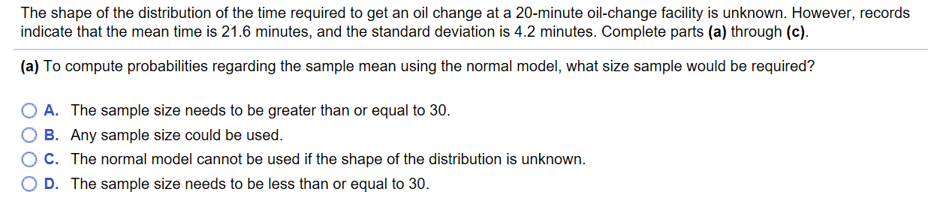

- Explain why the probability that one randomly selected vehicle will have an oil change time that is less than 20 minutes.

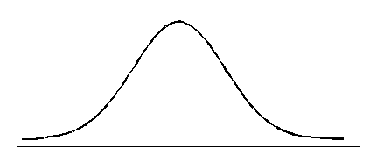

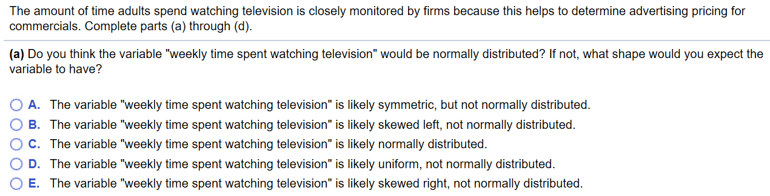

- The shape of the distribution of $\overline{x}$ is ___________________________________
- $μ_{\overline{x}}$ = ________________________
- $σ_{\overline{x}}$ = ________________________

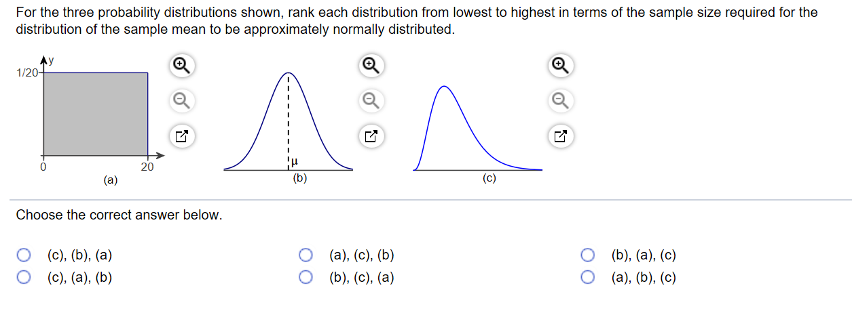

Suppose you want to study the number of hours of sleep you get each evening. To do so, you look at the calendar and randomly select 10 days out of the next 300 days and record the number of hours you sleep.

- Explain why number of hours of sleep in a night by you is a random variable.

- Is the random variable “number of hours of sleep in a night” quantitative or qualitative?

- After you obtain your ten nights of data, you compute the mean number of hours of sleep. Is this a statistic or a parameter? Why?

- Is the mean number of hours computed in part c a random variable? Why? If it is a random variable, what is the source of variation?

8.2 Sampling distribution of a sample proportion.
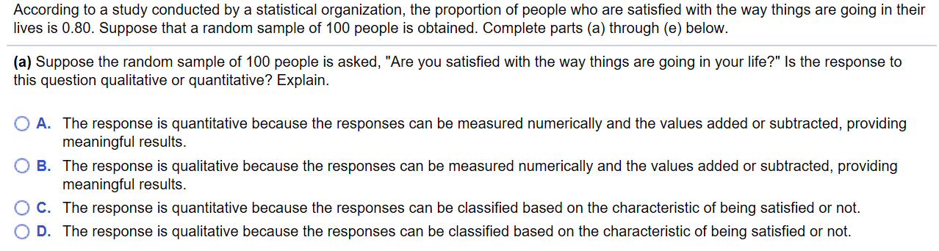

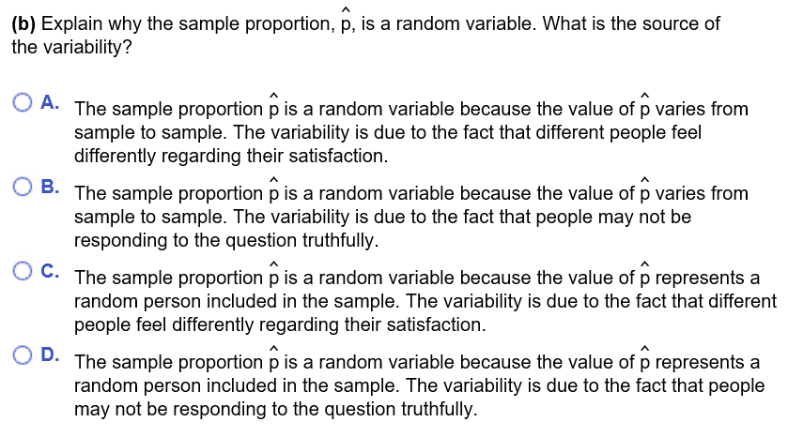
Since the sample size is no _______________ than _____% of the population size and $np\left(1-p\right)= ________≥10,$ the distribution of $\hat{p}$ is ______________________________ with
$μ_{\hat{p} }=________$ and $σ_{\hat{p} }=________$
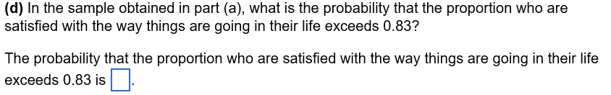

Conclusion: The probability that 74 or fewer people in the sample are satisfied is _____________, which (is/ is not) unusual because this probability (is/ is not) less than _____%

The proportion of passengers who miss a flight for which they have a reservation is 0.0995.
- Suppose a flight has 290 reservations. What is the probability that 25 or more passengers will miss the flight?

- Suppose a flight has 320 reservations, but only 300 seats on the plane. What is the probability that 300 or fewer passengers show up for the flight?

- Suppose a popular flight has 300 seats and 300 reservations. Because this flight is popular, the proportion of passengers with a reservation who miss the flight is only 0.04. You are booked on a later flight and put yourself on the stand-by list. There are 14 passenger names ahead of you. What is the probability you get on this flight?

